**Process Flow chart:**

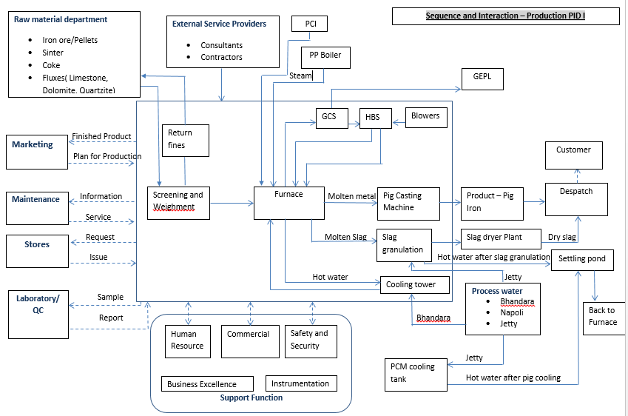

|  |  |  |
| --- | --- | --- |
| **Prepared By:**  Control Room In charge | **Reviewed & Issued By:**  Management Representative | **Approved By:**  Head – Operations PID1 |
| **Signature:** | **Signature:** | **Signature:** |
| **Review Date: 08.08.2022** | **Review Date: 08.08.2022** | **Review Date: 08.08.2022** |